Waste Detect FrontEnd Interface Designs.
- General Interfaces (User and Admin)
- Register
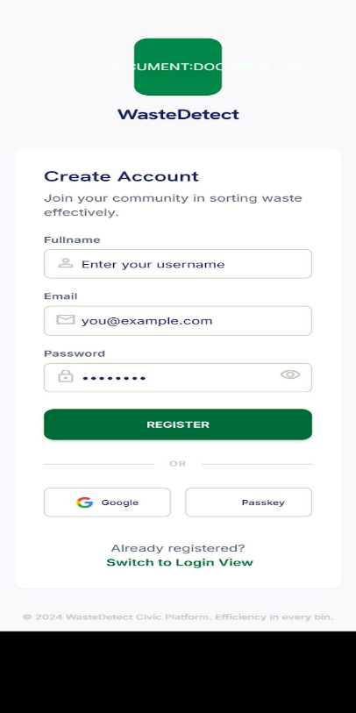
- Login
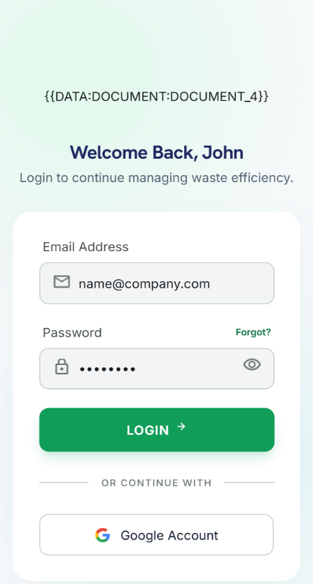
Note: I believe that we should include a field for the role during registration otherwise you find it unnecessary especially because the admin and the user will interact on different interfaces via the app.

- User Interfaces (Citizen)
- Scan
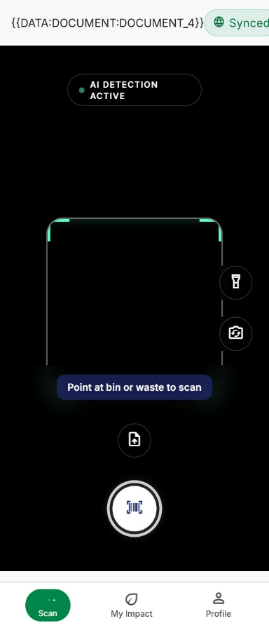
- Impact
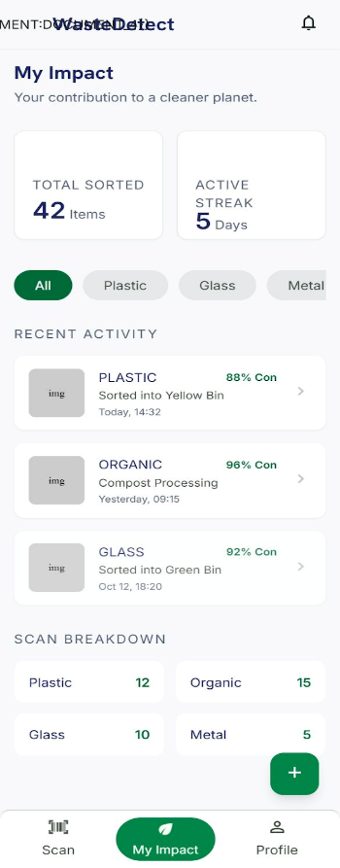
- Profile
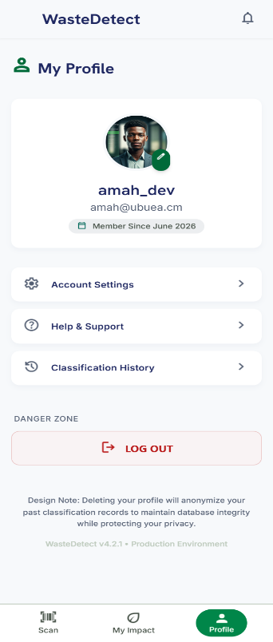
- Admin Interfaces (Waste Management Official, HYSACAM official for example)
- Admin Dashboard overview
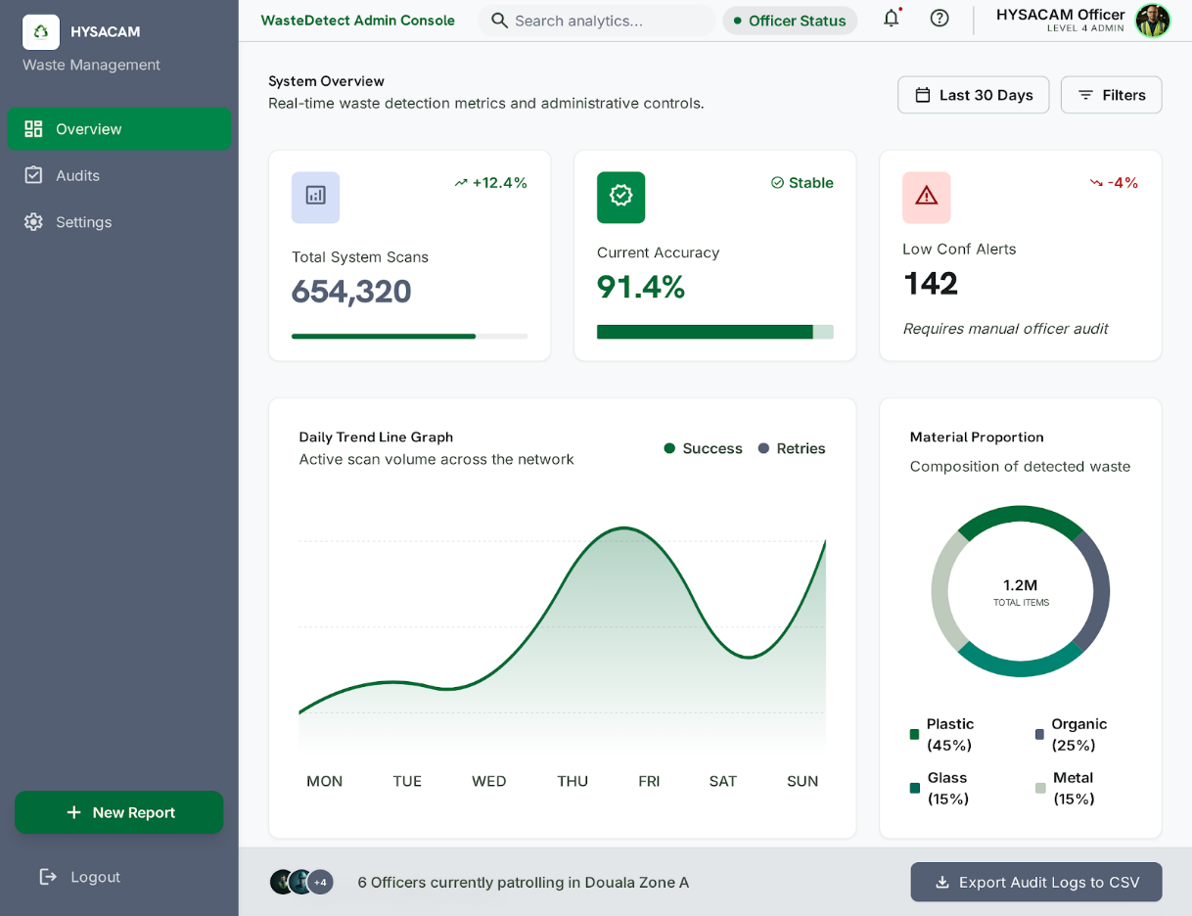

- Audits
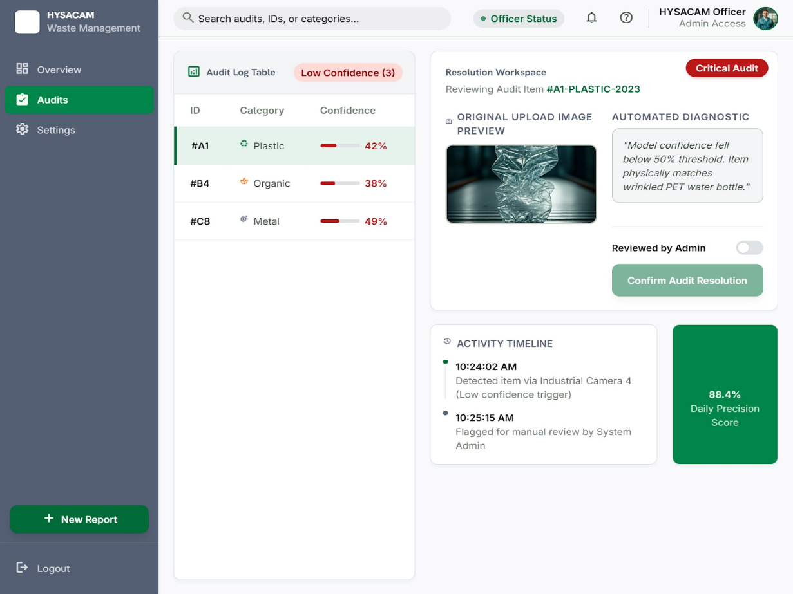

Note: You might have noticed that the admin interfaces are in landscape format (for computer displays) where as the user interfaces are in portrait mode (for mobile displays).

